TO BE RELEASED IMMEDIATELY Contact: Brad Miller
bradmiller@jaytv.com

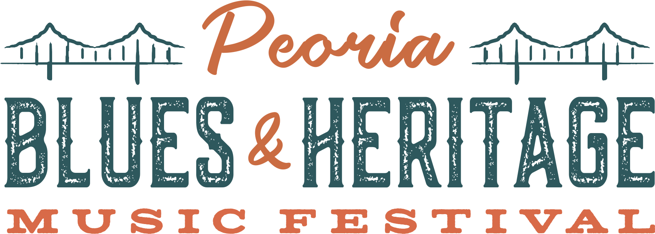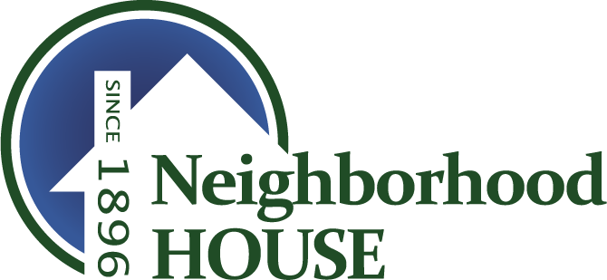

Jay Goldberg Events & Entertainment presents
PEORIA BLUES & HERITAGE MUSIC FESTIVAL
August 30th & 31st, 2019 • Peoria Riverfront • Peoria, Illinois

Peoria Blues and Heritage Music Festival Partners with Neighborhood House Peoria to Host Charity Coat Drive

Jay Goldberg Events & Entertainment is proud to present the 31st Annual Peoria Blues & Heritage Music Festival on August 30th and 31st at the beautiful Peoria Riverfront Festival Park in Peoria, IL. In anticipation of the 2019 festival, Jay Goldberg Events & Entertainment is proud to partner with Neighborhood House to host a charity coat drive leading up to and onsite at the festival. Patrons can drop their new or gently used coat at Neighborhood House Peoria before Friday, August 30th and receive a $10 voucher (25% discount) on their 2-Day GA Ticket to Peoria Blues and Heritage Festival 2019. Concertgoers can also donate their new or gently used coats at the main entrance of the festival on Friday, August 30th for $10 off their 2-Day GA Ticket.

Neighborhood house is located at 1020 S. Matthew, Peoria, IL 61605. Coats can be donated between the hours of 8:30AM – 4:30PM Monday – Friday beginning Monday, August 19 through Friday, August 30th. Limit 1 voucher per person. Voucher only redeemable at the gate. Learn more about Neighborhood House at nhpeoria.org.

The 2019 Peoria Blues & Heritage Music Festival lineup features The Kenny Wayne Shepherd Band, Here Come the Mummies, Tommy Castro & The Painkillers, The Jerry Garcia Band Featuring Melvin Seals and John Kadlecik of Dark Star Orchestra and Furthur, Ronnie Baker Brooks, Laith Al-Saadi, the Road To Memphis International Blues Challenge, and many more!

Celebrate Labor Day Weekend with 2 days of live music, delicious food, cold beer, unique vendors, and more! 2-Day and Single-Day GA, Party Pit, and VIP Tickets are on sale now at PBHFest.com.

Peoria Blues & Heritage Music Festival 2019 Afterparties Announced
The party doesn’t stop on the Riverfront! Join us at Kenny’s Westside Pub, located just up the street from the Riverfront, for the Official Peoria Blues & Heritage Music Festival 2019 Afterparties! Friday, August 30th features indie-folk rockers Arlo McKinley & The Lonesome Sound along with the circus-funk collective Sun Stereo. Saturday, August features guitarist Matthew Curry, plus the reggae-influenced jams of Aaron Kamm and the One Drops.

Entry into the afterparties is one of the MANY perks that come with the purchase of a VIP Ticket. To learn more and buy tickets now, visit PBHFest.com/afterparties.

2019 Full Lineup
Kenny Wayne Shepherd Band
Here Come The Mummies

Tommy Castro & The Painkillers
Ronnie Baker Brooks
JGB feat. Melvin Seals and John Kadlecik
Laith Al-Saadi

Aaron Kamm and The One Drops
Arlo Mckinley & The Lonesome Sound
Ben Miller Band
Hollow Down
Ida Mae
Jamie N Commons
Jocelyn & Chris Arndt
Kilborn Alley Blues Band
Matthew Curry
Peoria Rhythm Kings
Rockin' Billy and the Rhythm Riot
Still Shine
Sun Stereo

“Road To Memphis” International Blues Challenge
Peoria Blues & Heritage Music Festival is your opportunity to see the best of the independent blues bands competing for their place in history. Winners of the competition will be awarded a cash prize and perform at the 2020 International Blues Challenge in Memphis! Performers include Lizzi Neal Band, Hoosier Daddy, and Alex Jenkins & The Bombers. Don’t miss this exciting competition on Saturday, August 31st from 12:30-3:00PM CT on the Gateway Stage!

Exclusive Festival Hotel Rates Available
Exclusive Festival Hotel Rates Available!
Coming in from out of town? Check out our exclusive hotel rates in the Peoria area for Festival attendees! There are a limited number of rooms available, so be sure to reserve your room right away! Visit PBHFest.com/about/hotels for more info.

About the Festival
Live at Riverfront Festival Park in Peoria, IL on August 30th and 31st, 2019! Now in its 31st year, the PEORIA BLUES & HERITAGE MUSIC FESTIVAL is a Labor Day tradition you don’t want to miss! With the beautiful Illinois River valley serving as the festival backdrop, the PEORIA BLUES & HERITAGE MUSIC FESTIVAL celebrates the foundation of blues music, as well as all genres that stem from it, including roots, funk, soul and everything in between.

Previous performers include Albert Collins, Ben Folds, Blind Boys of Alabama, Buddy Guy, Canned Heat, Charlie Musselwhite, Dirty Dozen Brass Band, Dr. John, Eddie “The Chief” Clearwater, George Porter Jr., Here Come The Mummies, James Cotton, John Butler Trio, John Mayall & The Bluesbreakers, Johnny Winter Band, Keller Williams, Kenny Wayne Shepherd, Koko Taylor, Lonnie Brooks, Mavis Staples, O.A.R., Rebirth Brass Band, Robert Cray, Robert Randolph & The Family Band, Taj Mahal, Victor Wooten, Walter Trout, and many more.

Exclusive Festival Hotel Rates Available
Exclusive Festival Hotel Rates Available!
Coming in from out of town? Check out our exclusive hotel rates in the Peoria area for Festival attendees! There are a limited number of rooms available, so be sure to reserve your room right away!

More information on the festival is available at the official festival website and social links:
Website: www.PBHFest.com
Tickets: www.PBHFest.com/tickets
Lineup: www.PBHFest.com/lineup
Schedule: www.PBHFest.com/schedule
Facebook Page: www.facebook.com/peoriabluesandheritagemusicfestival/
Facebook Event: https://www.facebook.com/events/378683356095858/
Twitter: www.twitter.com/pbhfest
Instagram: www.instagram.com/pbhfest

Produced by Jay Goldberg Events & Entertainment in association with the Illinois Blues Coalition. For more info, visit www.JayTV.com

###

