TO BE RELEASED AT 12:00PM CT ON FRIDAY, JULY 19TH Contact: Brad Miller
bradmiller@jaytv.com

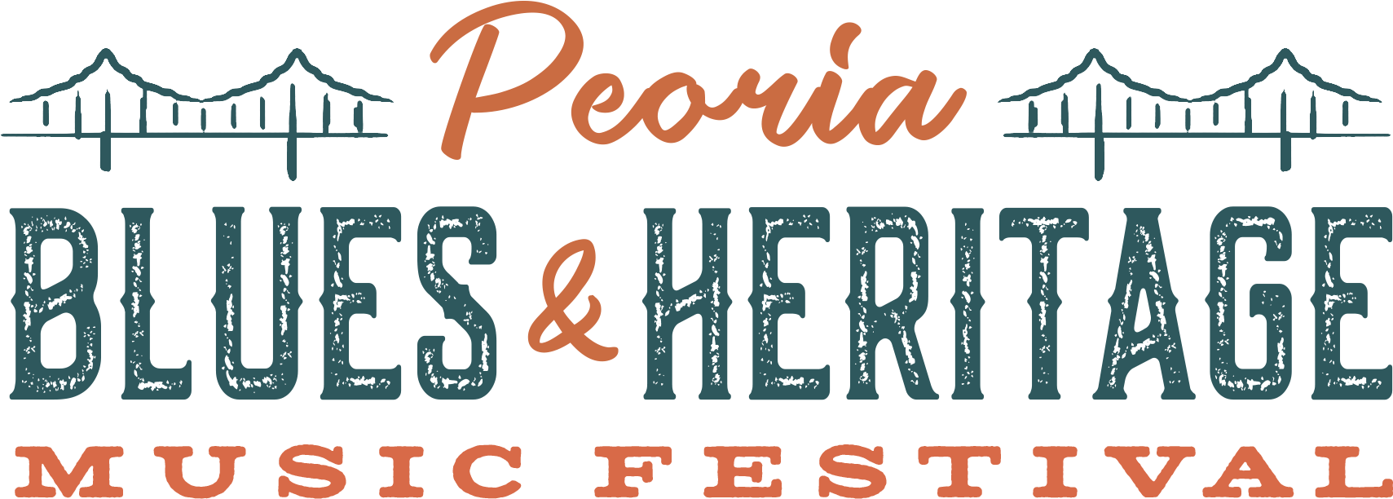
Jay Goldberg Events & Entertainment presents
PEORIA BLUES & HERITAGE MUSIC FESTIVAL
August 30th & 31st, 2019 • Peoria Riverfront • Peoria, Illinois

2019 Peoria Blues and Heritage Music Festival Full Artist Lineup and Schedule Released!
Single Day Tickets Go On Sale and Early Bird Pricing Ends Friday, July 26th at 12PM CT

Jay Goldberg Events & Entertainment in association with the Illinois Blues Coalition, 99.9 WWCT, Pekin Insurance, and Lenny The Lawyer is proud to announce the full lineup and schedule for the 31st Annual Peoria Blues & Heritage Music Festival this Labor Day Weekend! Friday, August 30th will feature “terrifying funk-rockers beyond the grave” Here Come The Mummies, plus JGB Ft. Melvin Seals & John Kadlecik, and blues guitarist Ronnie Baker Brooks! Saturday, August 31st will feature Louisiana born axeman and songsmith Kenny Wayne Shepherd Band, plus blues and soul legend Tommy Castro & The Painkillers, and Laith Al-Saadi of NBC’s The Voice. See the full lineup and schedule at www.PBHFest.com.

Tickets On Sale Now – Early Bird Pricing Ends Next Friday!
Early Bird 2-Day GA, Party Pit, and VIP Tickets are on sale now at www.PBHFest.com/tickets. But hurry – Early Bird Pricing on 2-Day GA and Party Pit tickets ends next Friday, July 26th at 12PM CT! With tickets starting at just $35, don’t miss out on your chance to experience #PBHFest19 at the lowest price! Buy now at www.PBHFest.com/tickets.

Can’t make the whole weekend? We’ve got you covered! Single Day GA, Party Pit, and VIP Tickets go on sale next Friday, July 26th at 12PM CT at www.PBHFest.com/tickets.

VIP Amenities include Express VIP Entry, Special VIP Enhanced Viewing Area at Main Stage, VIP Bar in Viewing Area, Entry into the Late Night shows in Peoria, and an Official Festival T-Shirt (2-Day VIP Upgrade Only)!

2019 Full Lineup – new artists in bold:
Kenny Wayne Shepherd Band
Here Come The Mummies

Tommy Castro & The Painkillers
Ronnie Baker Brooks
JGB feat. Melvin Seals and John Kadlecik
Laith Al-Saadi

Aaron Kamm and The One Drops
Arlo Mckinley & The Lonesome Sound
Ben Miller Band
Hollow Down
Ida Mae
Jamie N Commons
Jocelyn & Chris Arndt
Kilborn Alley Blues Band
Matthew Curry
Peoria Rhythm Kings
Rockin' Billy and the Rhythm Riot
Still Shine
Sun Stereo

“Road To Memphis” International Blues Challenge
Peoria Blues & Heritage Music Festival is your opportunity to see the best of the independent blues bands competing for their place in history. Winners of the competition will be awarded a cash prize and perform at the 2020 International Blues Challenge in Memphis! Performers include Lizzi Neal Band, Hoosier Daddy, and Alex Jenkins & The Bombers. Don’t miss this exciting competition on Saturday, August 31st from 12:30-3:00PM CT on the Gateway Stage!

About the Festival
Live at Riverfront Festival Park in Peoria, IL on August 30th and 31st, 2019! Now in its 31st year, the PEORIA BLUES & HERITAGE MUSIC FESTIVAL is a Labor Day tradition you don’t want to miss! With the beautiful Illinois River valley serving as the festival backdrop, the PEORIA BLUES & HERITAGE MUSIC FESTIVAL celebrates the foundation of blues music, as well as all genres that stem from it, including roots, funk, soul and everything in between.

Previous performers include Albert Collins, Ben Folds, Blind Boys of Alabama, Buddy Guy, Canned Heat, Charlie Musselwhite, Dirty Dozen Brass Band, Dr. John, Eddie “The Chief” Clearwater, George Porter Jr., Here Come The Mummies, James Cotton, John Butler Trio, John Mayall & The Bluesbreakers, Johnny Winter Band, Keller Williams, Kenny Wayne Shepherd, Koko Taylor, Lonnie Brooks, Mavis Staples, O.A.R., Rebirth Brass Band, Robert Cray, Robert Randolph & The Family Band, Taj Mahal, Victor Wooten, Walter Trout, and many more.

Exclusive Festival Hotel Rates Available!
Coming in from out of town? Check out our exclusive hotel rates in the Peoria area for Festival attendees! There are a limited number of rooms available, so be sure to reserve your room right away!

More information on the festival is available at the official festival website and social links:
Website: www.PBHFest.com
Tickets: www.PBHFest.com/tickets
Lineup: www.PBHFest.com/lineup
Schedule: www.PBHFest.com/schedule
Facebook Page: www.facebook.com/peoriabluesandheritagemusicfestival/
Facebook Event: https://www.facebook.com/events/378683356095858/
Twitter: www.twitter.com/pbhfest
Instagram: www.instagram.com/pbhfest
Hashtag: #PBHFest19

Produced by Jay Goldberg Events & Entertainment in association with the Illinois Blues Coalition. For more info, visit www.JayTV.com

###

